OUTPUT OF STUDENTMARK:

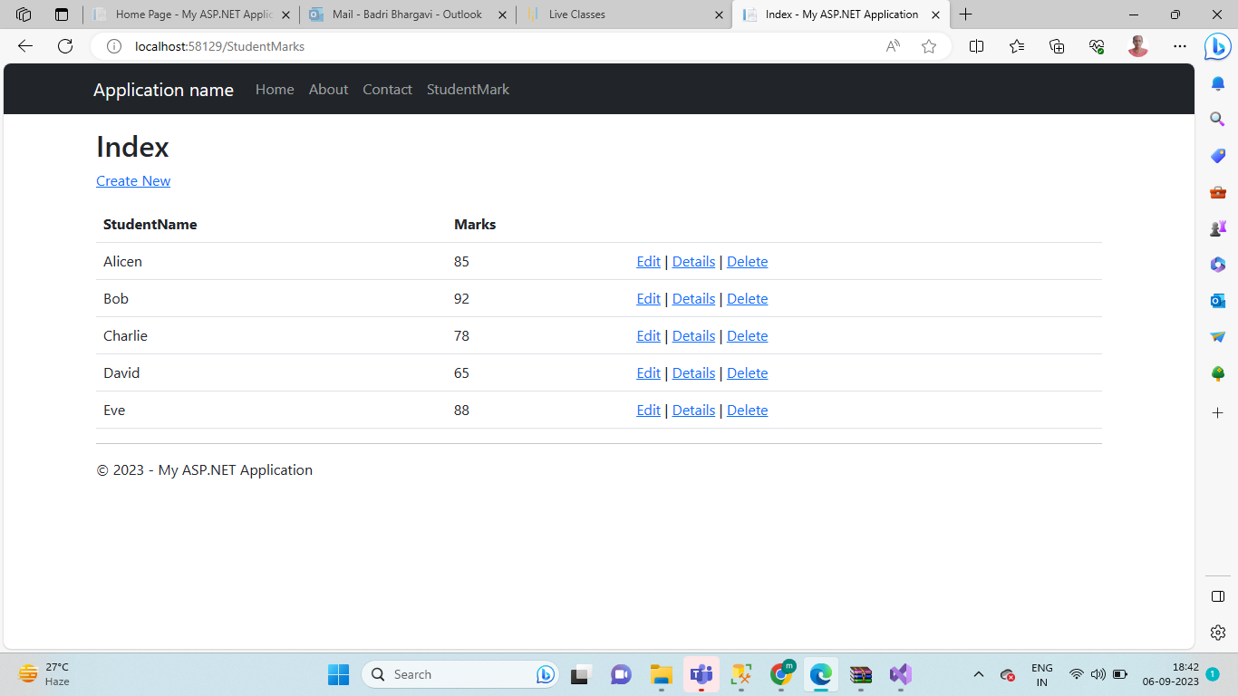

OUTPUT OF SQL QUERY:

